 | Challenge NRW | Klasse: | Datum: | KV
Mögliche Sprechprüfung als Ersatz für eine Klausur im Fach Englisch im Beruflichen Gymnasium

Jahrgangsstufe 13.1 – Fachbereich Wirtschaft und Verwaltung

Thema: Progress and responsibility

Prüfungsteil 1 (monologisches Sprechen)
Prüfungsteil 2 (an Gesprächen teilnehmen)
Gruppenprüfung
Vorbereitungszeit: 5 Minuten

Vorbereitung des monologischen Sprechens und an Gesprächen teilnehmen (Prüfungsteile 1 und 2 / Parts 1 and 2)

Für eine intensive Beschäftigung auch mit den relevanten sprachlichen Mitteln sei besonders auf die folgenden Skills files verwiesen:
- Language functions (S 1)
- Describing and analysing visuals (S 10)
- Speaking skills (S 13)
- Oral exams (S 14)

Desweiteren empfiehlt sich eine intensive Beschäftigung mit den folgenden Aufgabenformaten in den einzelnen Topics:
- writing a speech
- discussion
- role play
- working with a cartoon/diagram/infographic/graphic novel
- creating a poster
- carrying out an interview

Darüber hinaus gibt es in jedem Topic im ersten Teil Getting started eine zusammenhängende Aufgabe, die einen mündlichen Teil enthält und durch Useful phrases unterstützt wird. Die Topic task zum Abschluss des Kapitels bietet auch eine komplexe Aufgabe die häufig mündliche Diskussionselemente enhält.

Role card 1

You are doing an internship for Green Travel, a consultancy which advises cities and boroughs on sustainable traffic methods and mobility concepts. As a pioneer, Singapore is rolling out a green taxi company which will require an initial purchase of 400 environmentally friendly cars. This taxi company will be owned and run by the city council itself. The city has received offers from several car companies and forwards them to Green Travel for their advice regarding their suitability for the project.

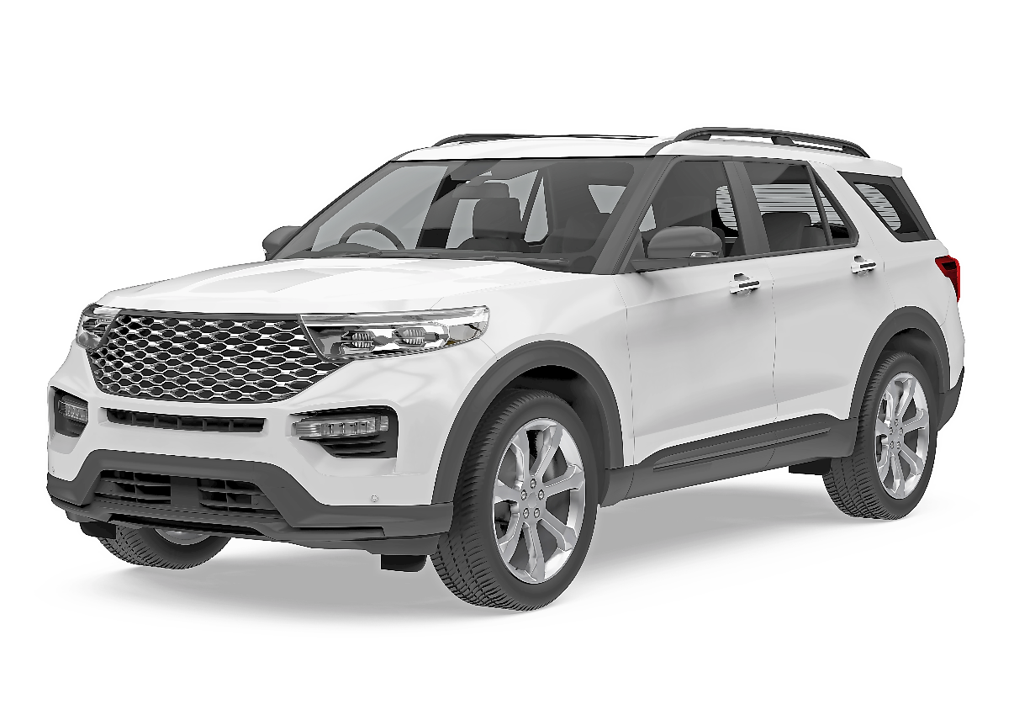

Part 1: Giving a short talk
Prepare a short talk of about five minutes in which you
a) describe and analyse the design of this new car.
b) comment on what this type of car would mean for the future of mobility. Do you agree with this idea?
c) give your opinion on what new ideas for cars should focus on to meet the requirements of sustainability.

Part 2: Group discussion
Based on your results from part 1, agree on possible regulations for smart cities regarding future traffic concepts. Which other measures could they introduce to make transportation in cities greener and more efficient? Discuss possible restrictions for vehicles which don’t meet sustainability requirements.

Role card 2

You are doing an internship for Green Travel, a consultancy which advises cities and boroughs on sustainable traffic methods and mobility concepts. As a pioneer, Singapore is rolling out a green taxi company which will require an initial purchase of 400 environmentally friendly cars. This taxi company will be owned and run by the city council itself. The city has received offers from several car companies and forwards them to Green Travel for their advice regarding their suitability for the project.
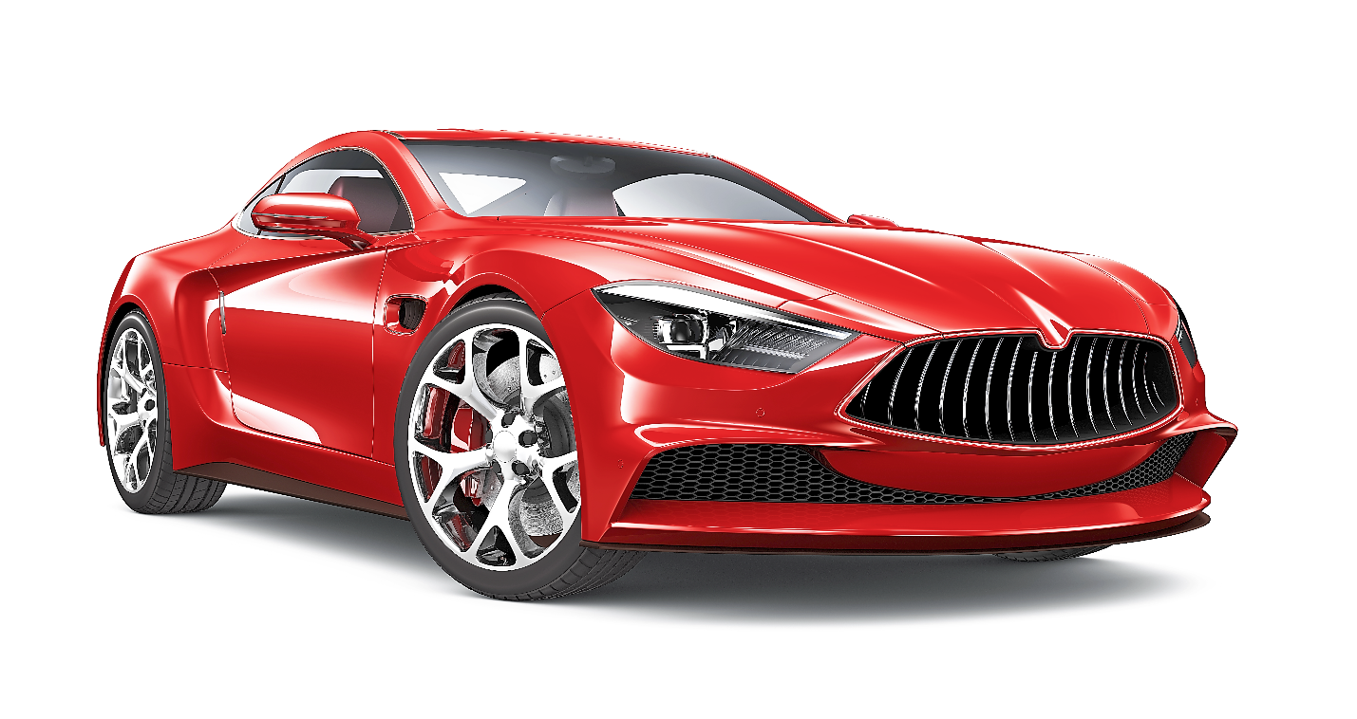

Part 1: Giving a short talk
Prepare a short talk of about five minutes in which you
a) describe and analyse the design of this new car.
b) comment on what this type of car would mean for the future of mobility. Do you agree with this idea?
c) give your opinion on what new ideas for cars should focus on to meet the requirements of sustainability.

Part 2: Group discussion
Based on your results from part 1, agree on possible regulations for smart cities regarding future traffic concepts. Which other measures could they introduce to make transportation in cities greener and more efficient? Discuss possible restrictions for vehicles which don’t meet sustainability requirements.

Role card 3

You are doing an internship for Green Travel, a consultancy which advises cities and boroughs on sustainable traffic methods and mobility concepts. As a pioneer, Singapore is rolling out a green taxi company which will require an initial purchase of 400 environmentally friendly cars. This taxi company will be owned and run by the city council itself. The city has received offers from several car companies and forwards them to Green Travel for their advice regarding their suitability for the project.

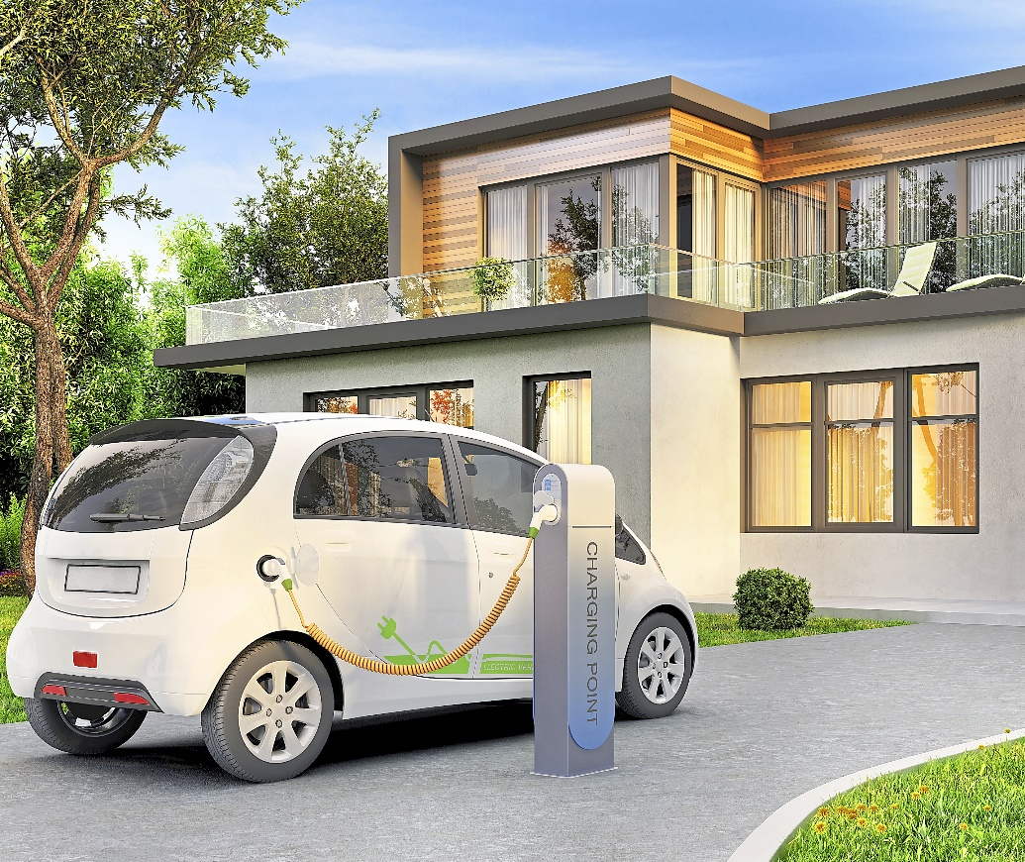

Part 1: Giving a short talk
Prepare a short talk of about five minutes in which you
a) describe and analyse the design of this new car.
b) comment on what this type of car would mean for the future of mobility. Do you agree with this idea?
c) give your opinion on what new ideas for cars should focus on to meet the requirements of sustainability.

Part 2: Group discussion
Based on your results from part 1, agree on possible regulations for smart cities regarding future traffic concepts. Which other measures could they introduce to make transportation in cities greener and more efficient? Discuss possible restrictions for vehicles which don’t meet sustainability requirements.

Mögliche Lösungen Prüfungsteil 1

Role card 1

a)
- Großer SUV, wahrscheinlich schwer und hoher Energiebedarf, hoher Energiebedarf in der Herstellung, hohe Emissionen, wahrscheinlich recht hoher Sicherheitsstandard
- Für Familien und Hobbies geeignet; viel Platz für Koffer, Einkäufe, Fahrräder, Hund usw.
b)
Individuelle Schülerlösung
c)
geringerer Energiebedarf, niedrige Emissionen, leicht, nachhaltig, eventuell elektrisch, benötigt wenig Parkraum

Role card 2

a)
- Sportliches, attraktives Design, wahrscheinlich hoher Energieverbrauch, hohe Emissionen, teuer, schnell, Geschwindigkeit ein Hauptmerkmal
- Geeignet für Leute ohne Kinder, die mit einem Auto Spaß haben wollen und Wert darauflegen, dass ihr Auto schön/sportlich aussieht, bietet aber wenig Platz, nicht zweckmäßig für alltäglichen Gebrauch
b)
Individuelle Schülerlösung
c)
geringerer Energiebedarf, niedrige Emissionen, leicht, nachhaltig, eventuell elektrisch, benötigt wenig Parkraum

Role card 3

a)
- Elektrisches Fahrzeug, kann zuhause geladen werden, wahrscheinlich sehr günstig im Unterhalt, unabhängig von Parkplatzproblemen, wenig stylisch, eher vernünftig
- Klein und leicht, kann länger fahren
- Relativ klein, für Städte geeignet, funktional
b)
Individuelle Schülerlösung
c)
geringerer Energiebedarf, niedrige Emissionen, leicht, nachhaltig, eventuell elektrisch, benötigt wenig Parkraum

Mögliche Lösungen Prüfungsteil 2 (alle Rollenkarten)

Individuelle Schülerlösung

