G
Mustertext

Writing a story

Eine Geschichte schreiben

Wenn du eine Geschichte schreiben sollst, erhältst du meistens eine Vorgabe.
Das kann ein Bild sein oder ein Satz, der am Anfang, in der Mitte oder am Ende
der Geschichte vorkommen soll.

In diesem Beispiel ist der Anfang vorgegeben:

Magic for sale  It was evening and there were no cars or people on the street.  I ran until I came to a big, old building, which looked dark and  dirty. The sign said, ‘Magic bought and sold here.’ I pushed the  door open.  So könnte die Geschichte fortgesetzt werden:  “Good evening, young lady,” said the old man behind the desk.  He spoke very slowly and looked at me closely. I knew he was  thinking, ‘What has she got for me?’  “Buying or selling?” he asked curiously.  “Er … selling… I think.” My voice sounded less nervous than I was.  My father would go crazy if he knew I was here, talking to a man  who could take some of my magic skills, put them into a bottle and  sell them to a stranger. But we needed money, and this was the  only way to get some fast. I hated this place, hated this man, but  he had what I needed, and I had what he wanted.  “Show me what you’ve got for me then,” he said.  Although I was really scared, I took a deep breath and showed him  my hands. His eyes suddenly looked round and shocked. “I can’t  believe it,” he said. … | Überschrift  Zeit  Erzähler, Ort  Figuren  besondere Fähigkeit  Handlung vorantreiben

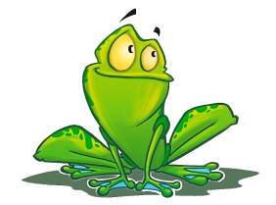 | Die unterstrichenen Wörter kannst du auch in deiner  Geschichte verwenden, um die Geschichte auszuschmücken  und spannend zu machen. Mehr solche Adjektive findest du  in der Datei Wortfelder.

