**Our London Tour**

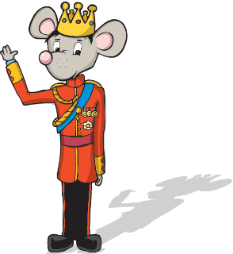

Time

Start:

Green Park

Time

Stop 2:

Place

Time

Stop 5:

Place

Time

Stop 4:

Place

Time

Stop 3:

Place