Tandem activity


1. Work with a partner. Partner A starts and makes two relative clauses.
It’s a country which …
It’s a person who …
2. Partner B makes sure that the relative clauses are correct.

3. He/She gives the correct answer and makes the next two sentences.

Partner A | Partner B
It’s a country …  has had a lot of inventors.  has many lakes and mountains.  (Scotland) | It’s a country which has had a lot of inventors.  It’s a country which has many lakes and mountains.
It’s a thing which was invented by James Watt.  It’s a thing which used coal to produce a lot of energy. | 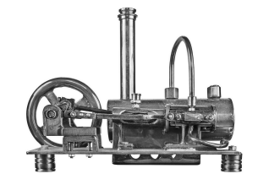  It’s a thing …  was invented by James Watt.  used coal to produce a lot of  energy.  (steam engine)
It’s a person …  from Karlsruhe.  invented the ‘running machine’.  (Karl Drais) | It’s a person who was from Karlsruhe.  It’s a person who invented the ‘running machine’.
It’s a machine which we use every day.  It’s a machine which Alexander Graham Bell invented. |   It’s a machine …  we use every day.  Alexander Graham Bell invented.  (the telephone)
It’s a place …  in the south of England.  was built over 4,000 years ago.  (Stonehenge) | It’s a place which is in the south of England.  It’s a place which was built over 4,000 years ago.
It’s an event which made William, Duke of Normandy, king of England.  It’s an event which changed the English language. | 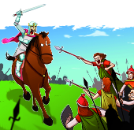  It’s an event …  made William, Duke of Normandy,  king of England.  changed the English language.  (Battle of Hastings)

