A musical journey across the USA (1)

A study¹ has shown that people like different styles of music across² the United States.
1. Read the texts and find out where people listen to which styles of music.
2. There is a map of the USA on the next page (2).
Draw lines from the symbols to the right places on the map.

Blues  Some people call Chicago the home of the blues. Many people around here love listening to singers like B.B. King and Bessie Smith. Their guitarists³ and bass players⁴ are very famous. Many people in Nashville and NYC listen to it too. | Country  There is one city that is famous for country music: Nashville. But people in Nevada, Texas and Florida also like listening to country music Did you know that Taylor Swift became famous as a country singer? | Punk  If you like Iggy Pop and The Ramones, you like the same music as the West Coast, Nashville and Orlando. Of course you can also find punk bands and their fans everywhere across the States. | 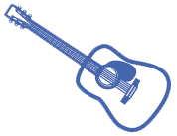  Indie  Are you a fan of indie music like Florence and the Machine, Bon Iver and Sufjan Stevens? Then you’ll find a lot of friends and concerts on the West Coast, especially⁵ in California. But many people in Florida also listen to this style of music.
Rap & Hip-Hop  New York City, Miami and Los Angeles have a long history when it comes to Rap and Hip-Hop. Minneapolis and Seattle also love listening to famous artists⁶ like Drake, Macklemore, the Beastie Boys, Eminem and many others. | Pop  Millions of people love pop music and artists like Justin Bieber and Beyoncé. Lots of people seem⁷ to listen to pop music in Los Angeles and the rest⁸ of California. But pop music is also very popular in Miami and Seattle. | 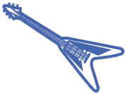  Rock  The Rolling Stones, Nirvana, AC/DC and Guns N’ Roses are some famous rock bands. These and many other bands have made rock music popular in all parts of America. But lots of their fans live in New York City, Minneapolis and New Orleans. | Jazz  New Orleans is the home of jazz, but Portland and New York City also love jazz music. Miles Davis, Louis Armstrong and Nina Simone were big jazz artists. Gregory Porter and Esperanza Spalding are famous for their jazz music today.

3. Listen to some of the different styles of music. What music do you like to listen to? Why?
Useful websites:

http://www.movoto.com/blog/novelty-real-estate/americas-music/

http://www.digitalmusicnews.com/2016/03/01/the-most-popular-music-genre-in-every-u-s-state/
4. Choose an artist or a band that you like. Find out where in
the USA your artist or band is giving a concert soon.
Mark the place on the map.

5. Talk to a partner. What style of music does he/she like?
Which artist(s) or band(s) does he/she like?

¹ study – Studie; ² across – über, querdurch; ³ guitarist – Gitarrenspieler; ⁴ bass player – Bassspieler;
⁵ especially – besonders, vor allem; ⁶ artist – Künstler/in; ⁷ seem – scheinen; ⁸ rest – der Rest

A musical journey across the USA (2)

Read the texts on the first page (1). Where do people listen to which styles of music?
Draw lines from the symbol to the right places on the map.

NEW
YORK
CITY
EAST COAST

MIAMI
ORLANDO

FLORIDA
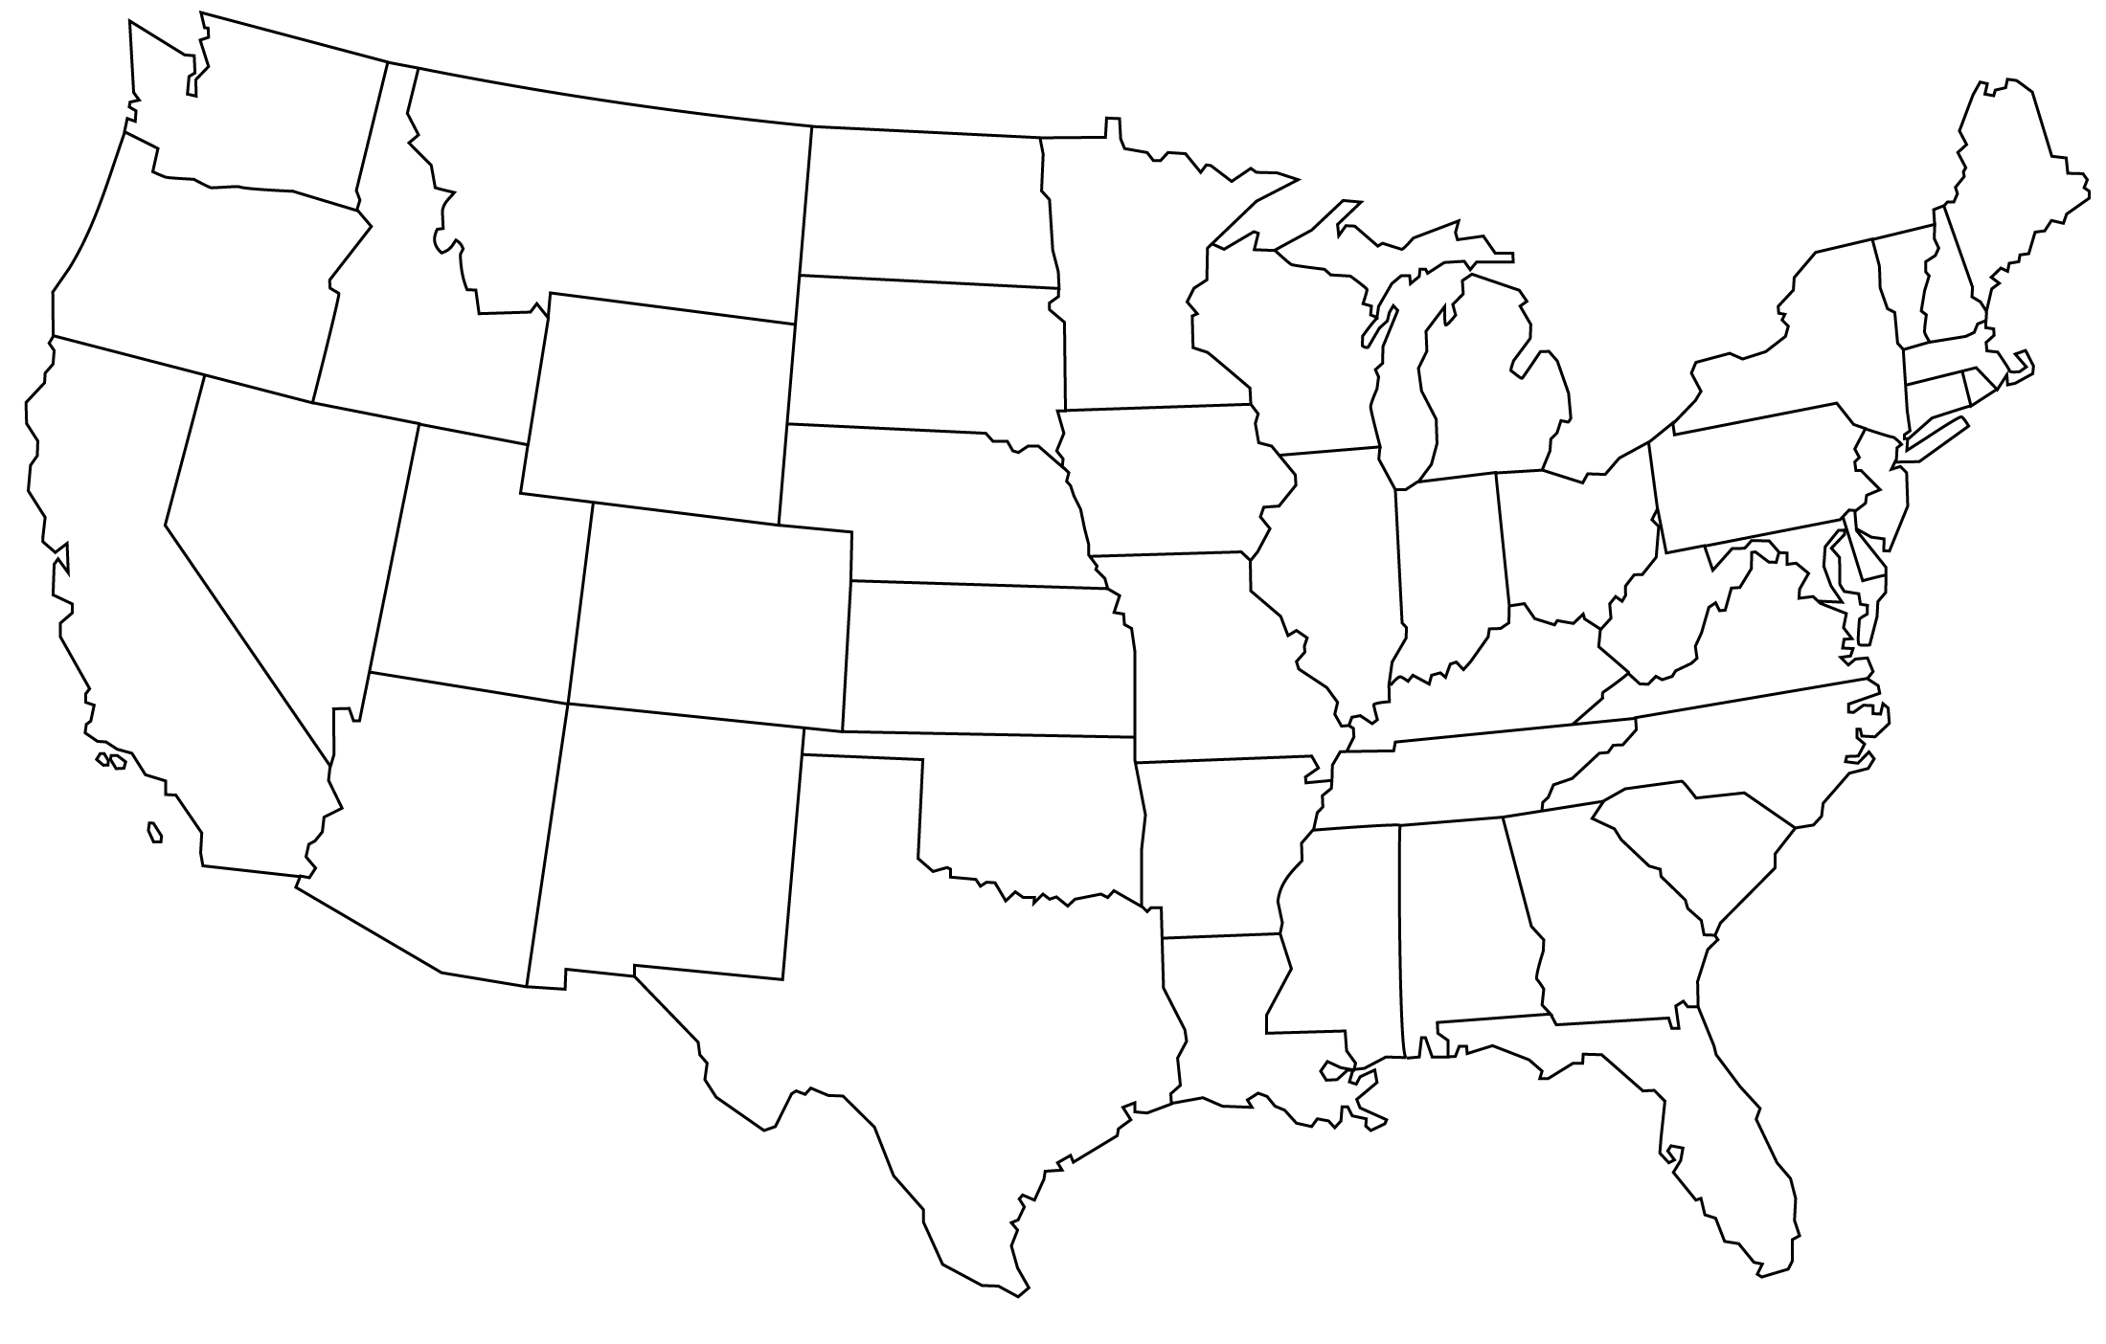

CHICAGO
NEW ORLEANS
NASHVILLE

MINNEAPOLIS
TEXAS

NEVADA
SEATTLE

PORTLAND
CALIFORNIA

LOS ANGELES

WEST COAST

