What do you know about the USA?
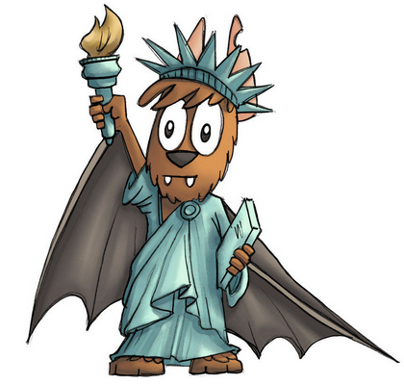
1 Answer as many questions as you can.

1. Name four typical American sports.

2. How do you call the old immigration station near New York Harbor?

3. What’s the name of the famous lady who will never leave New York?

4. Can you name five US presidents?

5. What color is the American president’s house?

6. Who gave the speech “I have a dream”?

7. What color are the cabs in New York City?

8. What is the highest mountain in Alaska called?

9. What is the American Midwest best known for?

10. Where in NYC do you go if you want to see a musical?

11. When was the Civil War?

12. Which country gave the Statue of Liberty as a present to the US in 1886?

13. How many stars and stripes are on the American flag? Why?

14. March 17th is an important date to people of … origin because it’s … .

15. Which city is famous for Mardi Gras and jazz music?

16. Who was the first president of the USA?

17. Where can you find the world-famous cable cars?

18. What happened on July 4th, 1776?

19. In which month is Thanksgiving celebrated in the US?

20. The ship the first pilgrims arrived on was called …

21. Can you name three Native American tribes?

22. If you go to Las Vegas, you meet a very famous person at nearly every corner. Who is it?

23. What is the Ku Klux Klan?

24. Where and when did the hip-hop culture start?

25. Who was the first African-American president of the USA?

26. Where were the country’s most dangerous criminals kept?

27. Who was the first person to reach America in 1492?

28. What do many people call Iowa?

29. Where can you find many Art Deco buildings?

30. Where does Spider Man live?

31. Where is Iron Man’s company?

32. At what age can you get a ‘learner’s permit’ and begin driving lessons?

33. Name the American city that is four times the size of Munich.

34. Which places do graffiti artists in New York City often use for their art?

35. What is a typical job for people who work in national parks across the USA?

36. If you want to see great street art, you go to ...

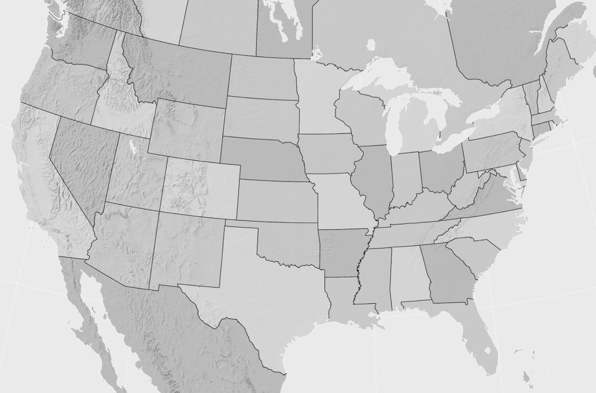
2 Find the names of the states. If you need help, take an atlas.
HI
AK
MIO
DC
DE
MD
NJ
RI
CT
MA
NH
WV
VA
KY
TN
NC
SC
FL
GA
AL
MS
LA
CO
NE
KS
AR
MO
OK
TX
NM
AZ
UT
NV
CA
OR
WA
ID
WY
MT
ME
VT
NY
PA
OH
IN
IL
IA
SD
ND
MN
WI
AL: ________________________ | AK: ________________________ | AZ: ________________________
AR: ________________________ | CA: ________________________ | CO: ________________________
CT: ________________________ | DE: ________________________ | FL: ________________________
GA: ________________________ | ID: _________________________ | IL: _________________________
IN: _________________________ | IA: _________________________ | KS: ________________________
KY: ________________________ | LA: ________________________ | ME: ________________________
MD: ________________________ | MA: ________________________ | MI: ________________________
MN: ________________________ | MS: ________________________ | MO: ________________________
MT: ________________________ | NE: ________________________ | NV: ________________________
NH: ________________________ | NJ: ________________________ | NM: ________________________
NY: ________________________ | NC: ________________________ | ND: ________________________
OH: ________________________ | OK: ________________________ | OR: ________________________
PA: ________________________ | RI: ________________________ | SC: ________________________
SD: ________________________ | TN: ________________________ | TX: ________________________
UT: ________________________ | VT: ________________________ | VA: ________________________
WA: ________________________ | WV: ________________________ | WI: ________________________
WY: ________________________ | HI: ________________________

What do you know about the USA? (solutions)
1 Answer as many questions as you can.

1. Name four typical American sports.
e.g. American football, softball, basketball, baseball, cheerleading
2. How do you call the old immigration station near New York Harbor?
Ellis Island
3. What’s the name of the famous lady who will never leave New York?
Lady Liberty
4. Can you name five US presidents?
e.g. Donald Trump, Barack Obama, George W. Bush, Bill Clinton, John F. Kennedy, …
5. What color is the American president’s house?
white
6. Who gave the speech “I have a dream”?
Martin Luther King Jr.
7. What color are the cabs in New York City?
yellow
8. What is the highest mountain in Alaska called?
Denali
9. What is the American Midwest best known for?
huge areas of flat farmland and small towns
10. Where in NYC do you go if you want to see a musical?
Broadway
11. When was the Civil War?
1861 – 1865
12. Which country gave the Statue of Liberty as a present to the US in 1886?
France
13. How many stars and stripes are on the American flag? Why?
There are 50 stars for the 50 states and 13 stripes for the 13 British colonies.
14. March 17th is an important date to people of … origin because it’s … .
Irish; St. Patrick’s Day
15. Which city is famous for Mardi Gras and jazz music?
New Orleans, Louisiana
16. Who was the first president of the USA?
George Washington
17. Where can you find the world-famous cable cars?
San Francisco
18. What happened on July 4th, 1776?
The colonies became independent from England.

19. In which month is Thanksgiving celebrated in the US?
November
20. The ship the first pilgrims arrived on was called …
The Mayflower
21. Can you name three Native American tribes?
e.g. Navajo, Cherokee, Sioux, Apache, Blackfeet, Choctaw, Chippewa, …
22. If you go to Las Vegas, you meet a very famous person at nearly every corner. Who is it?
Elvis Presley
23. What is the Ku Klux Klan?
a secret organization of white Americans who hate people of other races and religions
24. Where and when did the hip-hop culture start?
in the Bronx (New York City) in the late 1960s
25. Who was the first African-American president of the USA?
Barack Obama
26. Where were the country’s most dangerous criminals kept?
Alcatraz
27. Who was the first person to reach America in 1492?
Christopher Columbus
28. What do many people call Iowa?
A flyover state
29. Where can you find many Art Deco buildings?
on Miami’s South Beach
30. Where does Spider Man live?
in Queens (New York City)
31. Where is Iron Man’s company?
on Long Island (New York City)
32. At what age can you get a ‘learner’s permit’ and begin driving lessons?
between 14-16 years of age
33. Name the American city that is four times the size of Munich.
Los Angeles
34. Which places do graffiti artists in New York City often use for their art?
subway trains and buildings
35. What is a typical job for people who work in national parks across the USA?
ranger
36. If you want to see great street art, you go to ...
Brooklyn (New York City)

2 Find the names of the states. If you need help, take an atlas.
HI
AK
MIO
DC
DE
MD
NJ
RI
CT
MA
NH
WV
VA
KY
TN
NC
SC
FL
GA
AL
MS
LA
CO
NE
KS
AR
MO
OK
TX
NM
AZ
UT
NV
CA
OR
WA
ID
WY
MT
ME
VT
NY
PA
OH
IN
IL
IA
SD
ND
MN
WI

AL: Alabama | AK: Alaska | AZ: Arizona
AR: Arkansas | CA: California | CO: Colorado
CT: Connecticut | DE: Delaware | FL: Florida
GA: Georgia | ID: Idaho | IL: Illinois
IN: Indiana | IA: Iowa | KS: Kansas
KY: Kentucky | LA: Louisiana | ME: Maine
MD: Maryland | MA: Massachusetts | MI: Michigan
MN: Minnesota | MS: Mississippi | MO: Missouri
MT: Montana | NE: Nevada | NV: Nevada
NH: New Hampshire | NJ: New Jersey | NM: New Mexico
NY: New York | NC: North Carolina | ND: North Dakota
OH: Ohio | OK: Oklahoma | OR: Oregon
PA: Pennsylvania | RI: Rhode Island | SC: South Carolina
SD: South Dakota | TN: Tennessee | TX: Texas
UT: Utah | VT: Vermont | VA: Virginia
WA: Washington | WV: West Virginia | WI: Wisconsin
WY: Wyoming | HI: Hawaii

