Voluntourism (1)

1. Read the comment and answer the questions.

Save the world – a little?
1  5  10  15  20  25  30  35  40  45 | It’s in the word: volunteering + tourism = voluntourism. And tourism is a business that makes money for a lot of people and that is a major factor in the economies of many countries. ‘Voluntourism’ is the word used for the business that volunteering has become.  Every year, hundreds of thousands of young people from rich western countries go abroad to a poorer country to try and help some good cause¹, and also to travel, usually after they’ve just finished school.  The natural reaction of any person with a heart when seeing a person in need is to feel pity² and to want to to help. ‘Voluntourism’ has increased because media stories and photos of people in need³ are easily spread. Social media help to publicise⁴ and share them. These young people want to “do good”. But in spite of⁵ all the good intentions⁶, that can still be problematic. The way that voluntourism works possibly isn’t the best way to help. In fact there has been more and more criticism lately, that it can actually make things worse.  One criticism is that the volunteers are not in a position to and are not able to deal with the true problems in other countries at all.  For one thing, they are only there for a short period of time. And most volunteers do not have the special skills that would be truly useful for people in need. They may teach some basic English or help with construction work, but they don’t have the background to give medical help, for example. And realistically they can’t be expected to have these skills. After all they are ‘amateur’ helpers.  There is also some concern⁷ that voluntourism might distract people from the deeper roots of the problems – the economical, political, historical and social developments that lead to poverty.  It takes long, hard and often even boring work to make a change in these areas, and that’s just not as interesting and immediate⁸ as, for example, handing out food to poor children.  What is more, the idea of going to a poorer country to ‘save’ people there, is itself at least | 50  55  60  65  70  75 | questionable⁹. It automatically makes you think of them as ‘victims’. Especially people from countries that have contributed¹⁰ to the problems in poor countries, like former colonial powers, should be aware¹¹ of that.  So, does voluntourism actually do more damage than good? I don’t think that there are any easy answers to that question. But I think there are a few ideas that could help to make it more useful, for both the volunteers and the people they are trying to help:  First of all that means lower expectations: The volunteers should realise that they are not personally going to save anyone from poverty. But that’s OK.  And it’s nice for young people to get an opportunity to experience a different culture in a different part of the world. What’s important, though, is that this experience can and should be a starting point for them to develop a deeper interest in and a higher level of respect for the cultures of the countries which they visit.  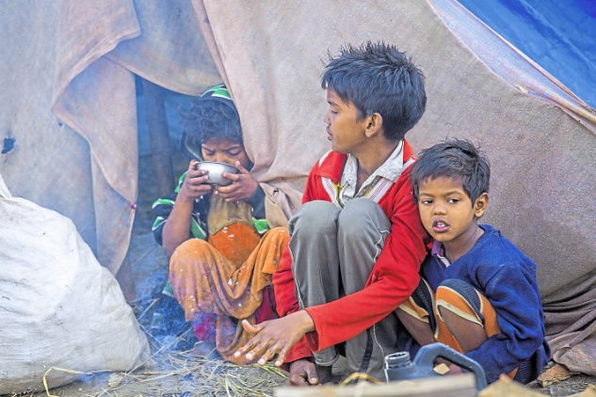  Ideally that could lead to a better under-standing of the causes of the problems there. Maybe that will cause changes in their actions in their normal, everyday lives at home, which might be more useful in the long run¹² – like paying attention to where and under what conditions the products they want to buy were produced, and developing political awareness and making well-informed decisions about what policies¹³ they want to support.
¹ cause – Zweck; ² pity – Mitleid; ³ in need – in Not, ⁴ publicise – bekannt machen ⁵ in spite of – trotz; ⁶ intention – Absicht; ⁷concern – Sorge; ⁸ immediate – unmittelbar; ⁹ questionable – fragwürdig; ¹⁰ to contribute – beitragen; ¹¹be aware – sich bewusst sein; ¹² in the long run - langfristig¹³ policy – politische Linie
Voluntourism (2)

2. Answer the questions.

1. Who takes part in volunteering pogrammes and where?

2. Why are volunteering programmes attractive for volunteers?

3. Why does the author think voluntourism isn’t very helpful?

4. What does the author recommend?

5. “The volunteers should realise that they are not personally going to save anyone from poverty. But that’s OK.” (lines 57-60). Give your opinion: Do you agree with the comment? Why (not)?

Voluntourism (1)

1. Read the comment and answer the questions.

Save the world – a little?
1  5  10  15  20  25  30  35  40  45 | It’s in the word: volunteering + tourism = voluntourism. And tourism is a business that makes money for a lot of people and that is a major factor in the economies of many countries. ‘Voluntourism’ is the word used for the business that volunteering has become.  Every year, hundreds of thousands of young people from rich western countries go abroad to a poorer country to try and help some good cause¹, and also to travel, usually after they’ve just finished school.  The natural reaction of any person with a heart when seeing a person in need is to feel pity² and to want to to help. ‘Voluntourism’ has increased because media stories and photos of people in need³ are easily spread. Social media help to publicise⁴ and share them. These young people want to “do good”. But in spite of⁵ all the good intentions⁶, that can still be problematic. The way that voluntourism works possibly isn’t the best way to help. In fact there has been more and more criticism lately, that it can actually make things worse.  One criticism is that the volunteers are not in a position to and are not able to deal with the true problems in other countries at all.  For one thing, they are only there for a short period of time. And most volunteers do not have the special skills that would be truly useful for people in need. They may teach some basic English or help with construction work, but they don’t have the background to give medical help, for example. And realistically they can’t be expected to have these skills. After all they are ‘amateur’ helpers.  There is also some concern⁷ that voluntourism might distract people from the deeper roots of the problems – the economical, political, historical and social developments that lead to poverty.  It takes long, hard and often even boring work to make a change in these areas, and that’s just not as interesting and immediate⁸ as, for example, handing out food to poor children.  What is more, the idea of going to a poorer country to ‘save’ people there, is itself at least | 50  55  60  65  70  75 | questionable⁹. It automatically makes you think of them as ‘victims’. Especially people from countries that have contributed¹⁰ to the problems in poor countries, like former colonial powers, should be aware¹¹ of that.  So, does voluntourism actually do more damage than good? I don’t think that there are any easy answers to that question. But I think there are a few ideas that could help to make it more useful, for both the volunteers and the people they are trying to help:  First of all that means lower expectations: The volunteers should realise that they are not personally going to save anyone from poverty. But that’s OK.  And it’s nice for young people to get an opportunity to experience a different culture in a different part of the world. What’s important, though, is that this experience can and should be a starting point for them to develop a deeper interest in and a higher level of respect for the cultures of the countries which they visit.  Ideally that could lead to a better under-standing of the causes of the problems there. Maybe that will cause changes in their actions in their normal, everyday lives at home, which might be more useful in the long run¹² – like paying attention to where and under what conditions the products they want to buy were produced, and developing political awareness and making well-informed decisions about what policies¹³ they want to support.
¹ cause – Zweck; ² pity – Mitleid; ³ in need – in Not, ⁴ publicise – bekannt machen ⁵ in spite of – trotz; ⁶ intention – Absicht; ⁷concern – Sorge; ⁸ immediate – unmittelbar; ⁹ questionable – fragwürdig; ¹⁰ to contribute – beitragen; ¹¹be aware – sich bewusst sein; ¹² in the long run - langfristig¹³ policy – politische Linie
Voluntourism (2)

2. Answer the questions.

1. Who takes part in volunteering pogrammes and where?
Usually young people/students who have just finished school (hundreds of thousands each
year) from rich western countries work as volunteers. They go to poor countries.

2. Why are volunteering programmes attractive for volunteers?
The young people feel pity when they see pictures and reports about people who need
help. And there are a lot of reports like these on the modern media. So the volunteers
want to do something to help. And they can experience life in a different country. So it’s
a good opportunity to do something for others and for yourself at the same time.

3. Why does the author think voluntourism isn’t very helpful?
Volunteers aren’t in the countries long enough. And they don’t have the neccessary
skills to help very much either. For example, most students don’t learn a lot about
medicine in school. They often prefer doing something that is interesting but not so
helpful to something that is boring but would help more, like doing politics.

4. What does the author recommend?
Volunteers shouldn’t expect to save ‘victims’. Instead they should go abroad to learn more
about their host countries and why they are poor countries. If the young people
understood these problems better, then they would change the way they act in a way that
is helpful in their own countries. That would already be a big step.

5. “The volunteers should realise that they are not personally going to save anyone from poverty. But that’s OK.” (lines 57-60). Give your opinion: Do you agree with the comment? Why (not)?
Musterlösung:
I agree with the comment because it’s important that people know that they can’t make everything better. If you think that you can end poverty and other world problems when you volunteer, you will be disappointed. It isn’t that easy to change things. But I also agree that it doesn’t matter if you can’t personally save anyone from poverty. You can still do positive things if you volunteer and help people. It’s just important to understand that you can change small things but you shouldn’t think you will solve the whole problem yourself.

