A poem: Hong Kong

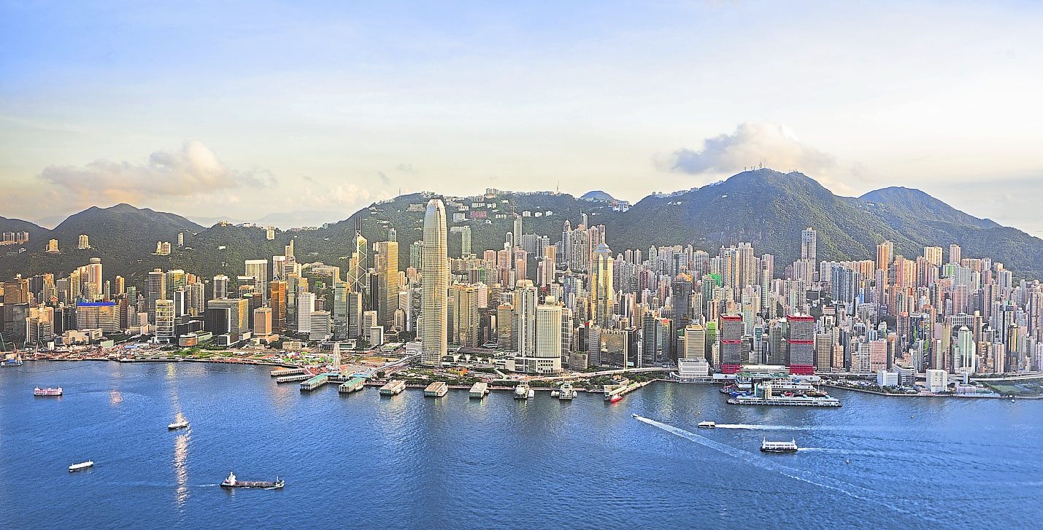

|  |
| --- |
| Tip |
| An acrostic is a form of poem. Here is an example:   |  |  |  | | --- | --- | --- | |  | C | ars | | no | I | sy | | public | T | ransport | | industr | Y |  | |

1. Complete the acrostic about Hong Kong.

You can use information from the photos   
and texts in your book (pp. 70–73).

|  |  |  |
| --- | --- | --- |
|  |  |  |
|  | H |  |
|  | O |  |
|  | N |  |
|  | G |  |
|  |  |  |
|  | K |  |
|  | O |  |
|  | N |  |
|  | G |  |
|  |  |  |



2. Work with a partner. Show him/her your acrostic and explain why you chose each word.

|  |
| --- |
| Useful phrases |
| This is my acrostic. I chose this word … because …  As you can see … I wrote down this word because …  This word makes me think of … This word is important because … |