Challenge NRW | Klasse: | Datum: | KV

Mögliche Sprechprüfung als Ersatz für eine Klausur im Fach Englisch im Beruflichen Gymnasium
Jahrgangsstufe 12.1 – Fachbereich Wirtschaft und Verwaltung
Thema: Communication in business – marketing and marketing analysis

Prüfungsteil 1 (monologisches Sprechen) Prüfungsteil 2 (an Gesprächen teilnehmen) Gruppenprüfung
Vorbereitungszeit: 5 Minuten

Vorbereitung des monologischen Sprechens und an Gesprächen teilnehmen (Prüfungsteile 1 und 2 / Parts 1 and 2)

Für eine intensive Beschäftigung auch mit den relevanten sprachlichen Mitteln sei besonders auf die folgenden
Skills files verwiesen:
- Language functions (S 1)
- Describing and analysing visuals (S 10)
- Speaking skills (S 13)
- Oral exams (S 14)

Desweiteren empfiehlt sich eine intensive Beschäftigung mit den folgenden Aufgabenformaten in den einzelnen Topics:
- writing a speech
- discussion
- role play
- working with a cartoon/diagram/infographic/graphic novel
- creating a poster
- carrying out an interview

Darüber hinaus gibt es in jedem Topic bei dem ersten Teil Getting Started eine zusammenhängende Aufgabe, die einen mündlichen Teil enthält und durch Useful phrases unterstützt wird. Die Topic task zum Abschluss des Kapitels bietet auch eine komplexe Aufgabe die häufig mündliche Diskussionselemente enthält.

As part of your internship in the UK, you work in the marketing department of Enjoy 2.0, a large producer of non-alcoholic drinks. Enjoy 2.0 has just launched GreenWater, a new soft drink consisting of mineral water and green tea. A range of six different aromas is supplied with each six-pack, so that every customer can create their truly individual mineral water.
As the product is about to be launched nationwide, the marketing director has asked you for your opinion about the marketing campaign so far. The overall campaign should attract average drinkers of soft drinks, but should also reflect the product’s innovation, freshness and uniqueness.
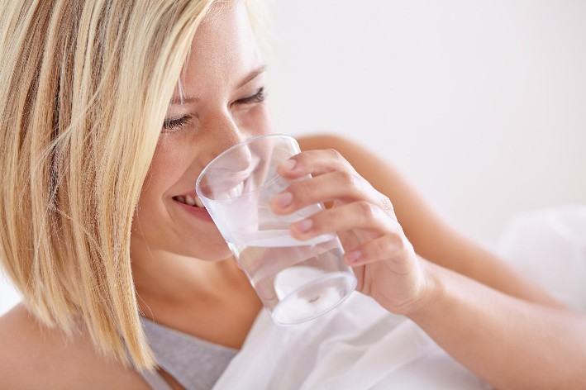

Part 1: Giving a short talk
Prepare a short talk of about five minutes in which you
- describe and analyse the two photos you have been given for the advertising campaign.
- say which photo you have chosen and why it is especially suitable for the new product and the target group.
- try to come up with innovative ideas about how to promote the new drink. Think about the kind of marketing and advertising you might use.

Part 2: Group discussion
Discuss each other’s photos and try to agree on one you all like. Again, summarise what makes this photo especially suitable for your new product GreenWater. Exchange views on further elements of the advertising campaign. What do you like/dislike about them? Try to find a compromise you can suggest to the marketing manager.

As part of your internship in the UK, you work in the marketing department of Enjoy 2.0, a large producer of non-alcoholic drinks. Enjoy 2.0 has just launched GreenWater, a new soft drink consisting of mineral water and green tea. A range of six different aromas is supplied with each six-pack, so that every customer can create their truly individual mineral water.
As the product is about to be sold nationwide at the end of next month, the marketing director has asked you for your opinion about the marketing campaign so far. The overall campaign should attract average drinkers of soft drinks, but should also reflect the product’s innovation, freshness and uniqueness.

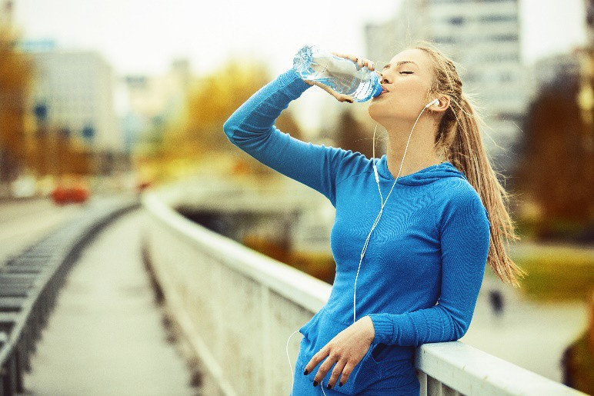

Part 1: Giving a short talk
Prepare a short talk of about five minutes in which you
- describe and analyse the two photos you have been given for the advertising campaign.
- say which photo you have chosen and why it is especially suitable for the new product and the target group.
- try to come up with innovative ideas about how to promote the new drink. Think about the kind of marketing and advertising you might use.

Part 2: Group discussion
Discuss each other’s photos and try to agree on one you all like. Again, summarise what makes this photo especially suitable for your new product GreenWater. Exchange views on further elements of the advertising campaign. What do you like/dislike about them? Try to find a compromise you can suggest to the marketing manager.

As part of your internship in the UK, you work in the marketing department of Enjoy 2.0, a large producer of non-alcoholic drinks. Enjoy 2.0 has just launched GreenWater, a new soft drink consisting of mineral water and green tea. A range of six different aromas is supplied with each six-pack, so that every customer can create their truly individual mineral water.
As the product is about to be sold nationwide at the end of next month, the marketing director has asked you for your opinion about the marketing campaign so far. The overall campaign should attract average drinkers of soft drinks, but should also reflect the product’s innovation, freshness and uniqueness.
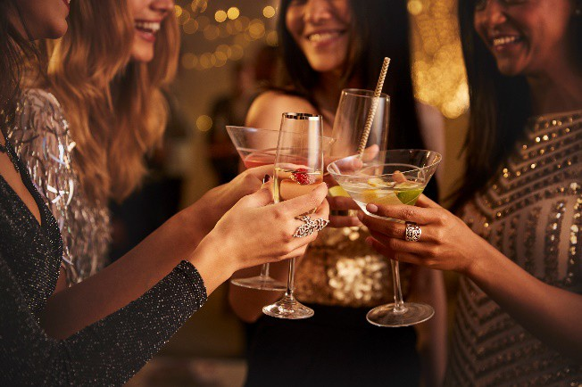

Part 1: Giving a short talk
Prepare a short talk of about five minutes in which you
- describe and analyse the two photos you have been given for the advertising campaign.
- say which photo you have chosen and why it is especially suitable for the new product and the target group.
- try to come up with innovative ideas about how to promote the new drink. Think about the kind of marketing and advertising you might use.

Part 2: Group discussion
Discuss each other’s photos and try to agree on one you all like. Again, summarise what makes this photo especially suitable for your new product GreenWater. Exchange views on further elements of the advertising campaign. What do you like/dislike about them? Try to find a compromise you can suggest to the marketing manager.

Role card 1

a)
- Nahaufnahme einer jungen Frau mit blonden Haaren; sie trinkt ein Glas Wasser und lächelt
- Helles Foto; positive, klare Botschaft: Frische
- Attraktiver junger Mann trinkt Wasser und lächelt
- Leicht distanziert; wir sehen den Körper und einen Krug Wasser auf der Theke
b)
Individuelle Schülerlösung c)
Mögliche Lösung: Virale Kampagne im Internet, Sponsoring von Sportveranstaltungen, Großveranstaltungen usw.

Role card 2

a)
- Eine junge Frau sitzt auf einer Bank im Park und trinkt aus einer Getränkedose
- Trägt Sportbekleidung und Turnschuhe und sieht fit und gesund aus; macht Pause vom Sport, erfrischt sich mit dem Getränk
- Hört Musik; trägt Kopfhörer; in der Stadt mit Fahrzeug und Gebäuden im Hintergrund
b)
Individuelle Schülerlösung c)
Mögliche Lösung: Virale Kampagne im Internet, Sponsoring von Sportveranstaltungen, Großveranstaltungen usw.

Role card 3

a)
- Mehrere Frauen stoßen mit alkoholischen Getränken oder Cocktails in chicen Gläsern an
- Abendzeit; formelle, glänzende, chice Klamotten
- Ein langer Esstisch formell eingedeckt mit Tellern, Gläsern und Besteck; keine Menschen zu sehen
b)
Individuelle Schülerlösung c)
Mögliche Lösung: Virale Kampagne im Internet, Sponsoring von Sportveranstaltungen, Großveranstaltungen usw.

(alle Rollenkarten)
Individuelle Schülerlösung mit Fokus auf Image, Zielgruppe (Alter, Einkommen, Unterhaltungskanäle etc.), Preis und Vertriebswege, Marketingstrategien müssen darauf abgestimmt sein und auch begründet werden

