Working conditions

1. Look at the picture and describe the working conditions in this Indian factory. ⭢ S20 Describing a picture

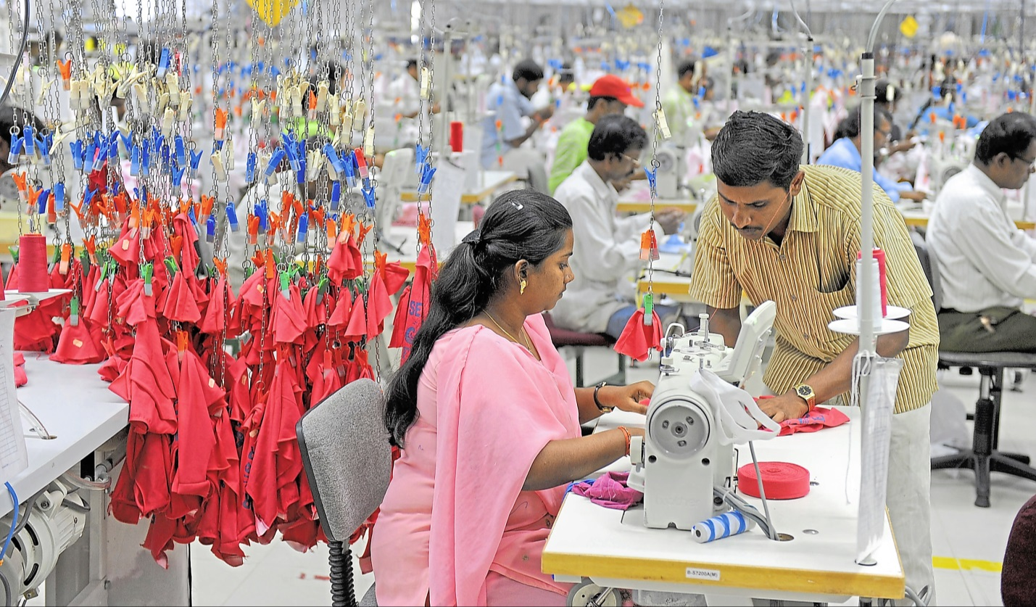



2. Do internet research about working conditions in so-called ‘sweatshops’ and write a report for your school magazine. ⭢ S3 Finding information

|  |  |
| --- | --- |
|  | Notes: |

|  |  |
| --- | --- |
| Useful phrases |  |
| working conditions • safety • child labour • long working hours • small rooms • few holidays • low pay • dangerous chemicals • short breaks • hard work • old machines • hire and fire • labour laws • medical care |