Working conditions

1. Look at the picture and describe the working conditions in this Indian factory. ⭢ S20 Describing a picture

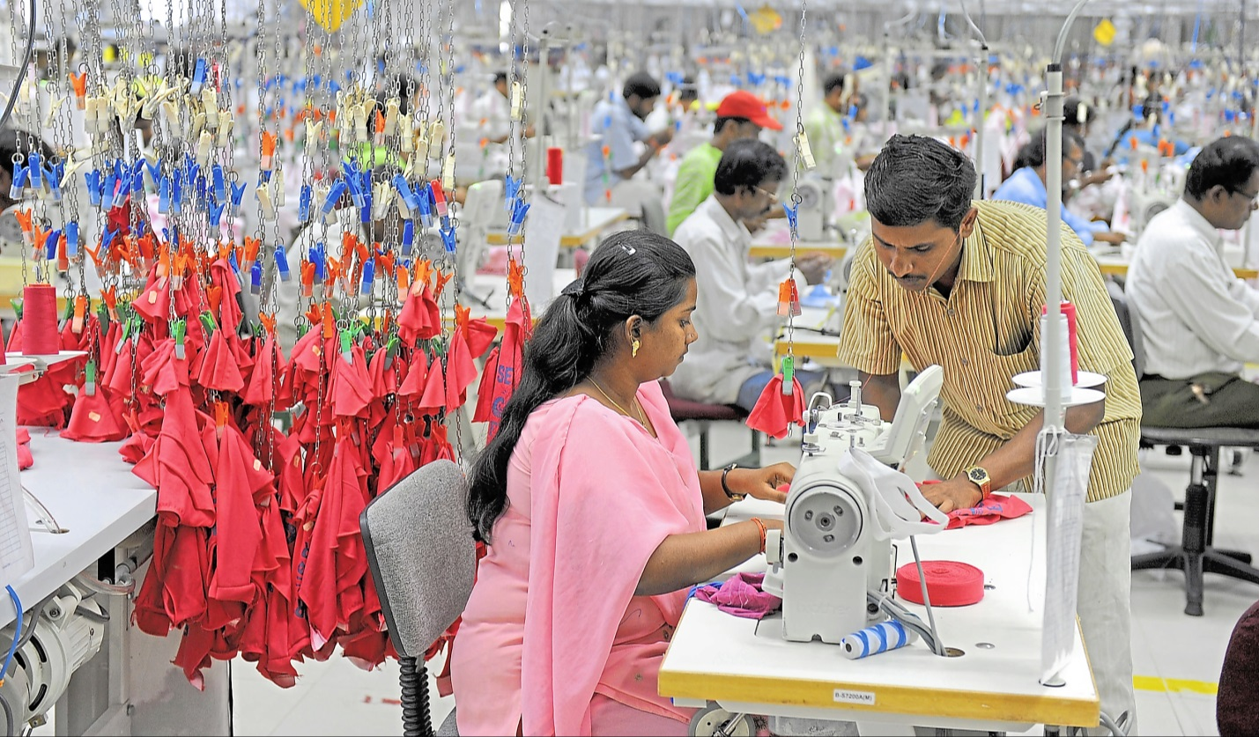



2. Do internet research about working conditions in so-called ‘sweatshops’ and write a report for your school magazine. ⭢ S3 Finding information

|  |  |
| --- | --- |
|  | Notes:  – sweatshop = factory with very bad working conditions; often clothes factories in poor  countries (e.g. Bangladesh, India) that make clothes that are sold all over the world  - working conditions: hard work; often difficult, sometimes even dangerous; either  no strict rules for the company e.g. for safety) or the factories ignore these rules; wages  for workers are very low (that’s how companies decide where they build factories);  there are even children working there; people have to work very long hours |

|  |  |
| --- | --- |
| Useful phrases |  |
| working conditions • safety • child labour • long working hours • small rooms • few holidays • low pay • dangerous chemicals • short breaks • hard work • old machines • hire and fire • labour laws • medical care |