Saving a baby elephant

1  5  10  15  20 | Nonkululeko – A story of freedom  10th May 2017 – Kruger National Park  An awful scene was discovered in the bush last Tuesday: the dead bodies of a family of five elephants. Each of them had been shot by hunters. The hunters had then quickly cut off the elephants’ ivory tusks and run away. A huge hunt to catch the killers began.  Back at the scene of the shooting, the rangers heard something moving in the grass. It was a small baby elephant! After it had spent the night alone with the bodies of its dead family, the poor animal was in a very bad state. Like a human baby, elephants need their mother’s milk for the first few months of their lives. They can’t survive without a mother. Usually, when hunters kill the mother, the babies walk around the bush until they die of hunger. But this time the rangers were able to catch it and transport it to the nearest airport, where it was flown to a wildlife centre for elephants.  They will take good care of Nonkululeko – that’s the elephant’s new name – at the wildlife centre. Nonkululeko will have a keeper with her for 24 hours a day who will give her milk every | 25  30  35  40 | three hours, night and day, and keep her warm with a blanket. A keeper will sleep next to her at night. The keepers can’t be exactly like a mum, but they can come close to it.  One keeper who has worked with elephants for 30 years said: “Elephants have all the best qualities that humans have, and not many of the bad qualities.”  Nonkululeko has a long road ahead of her. But she seems very friendly and has made contact with the other elephants. One day they hope she will be strong enough to return to the bush. Nonkululeko means ‘freedom’ in Zulu, one of South Africa’s languages. Hopefully this story will have a happy ending and Nonkululeko will be free again soon.  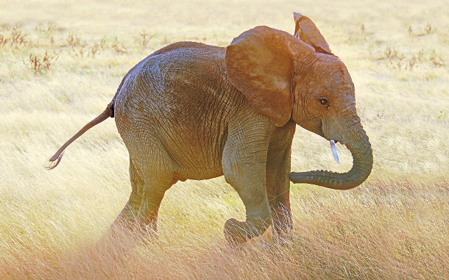

1. Read the text. Use a dictionary for any words you don’t know.

2. Answer the questions about the text in your own words.
a) What happened in the bush?

b) Why was the baby elephant in a bad state?

c) How will the wildlife centre care for the baby elephant?

d) What will happen to Nonkululeko in the future?

