I have a dream.

|  |
| --- |
| Tip |
| You can watch Martin Luther King’s speech on the internet. |

Martin Luther King Jr. gave his famous ‘I have a dream’ speech   
in Washington, D.C. in 1963. In his speech King talks about his   
hopes and dreams for the United States and the American people.

1. Read about some of the dreams that Martin Luther King Jr.   
 talked about in his speech.

I have a dream that white people and colored1 people will live and work together.

I have a dream that the USA will be a place where character2 is more important than the color of your skin3.

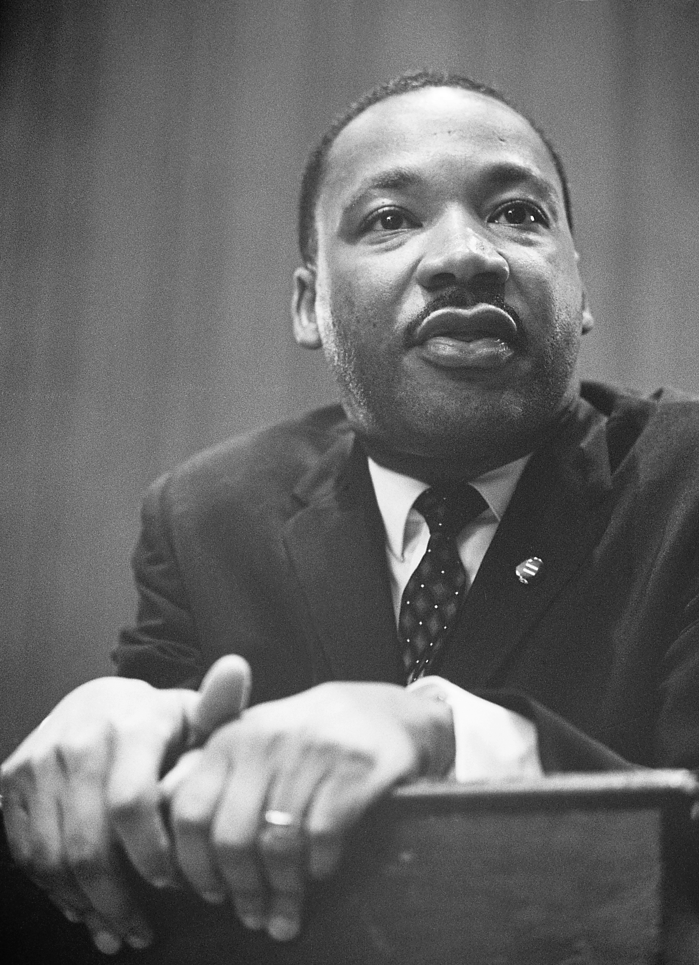

I have a dream that this country will be a safe place for my four children.

I have a dream that there will   
be equality4 and freedom for everybody.



2. Talk to a partner: What were King’s dreams? Do you think his dreams have come true?

3. What is your dream? Write down some ideas in the speech bubbles.

Share your ideas with a partner and in class. → M Think-pair-share

I have a dream …

I have a dream …

I have a dream …

1 colored – farbig, bunt; 2 character – Charakter; 3 color of skin – Hautfarbe; 4 equality – Gleichberechtigung