A rubbish problem

1  5  10  15  20 | Hong Kong is drowning in waste  Hong Kong is a modern, attractive city that’s famous for its skyscrapers and high-tech environment. However, the city also has a problem: There is simply too much waste.  Hong Kong is situated on several islands and doesn’t have very much space for landfill sites, places where rubbish is taken. For a long time, Hong Kong shipped over 90% of its waste and recyclables to China. In 2017, however, China decided not to take Hong Kong’s waste  anymore in order to reduce its own pollution. This means that Hong Kong has a massive rubbish problem: It doesn’t know where to put all its waste. And Hong Kong’s seven million residents produce a lot of rubbish.  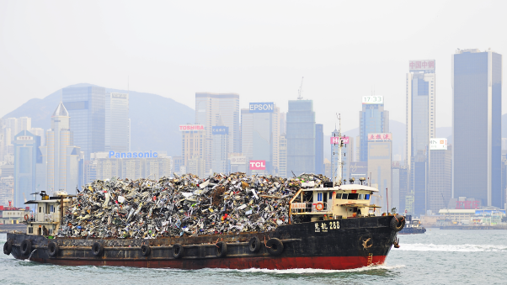  Some facts and figures  An average person in Hong Kong throws away about 1.4 kg of rubbish every day.  Hong Kong produces about 5.6 million tonnes of waste every year. Only a little  of that waste is recycled.  Hong Kong’s food waste alone could fill about 300 double decker busses per day. | 25  30  35  40  45 | 13 landfill sites have already been filled up during Hong Kong’s history.  5.2 million plastic bottles are thrown away every day.  Some solutions  The government in Hong Kong is trying to teach people how important it is to recycle. There are more and more bins available in the city that let people sort their waste (e.g. glass, plastic and paper go in different bins).  But more importantly, there are also strategies to reduce waste in the first place. The University of Hong Kong, for example, has banned small plastic bottles from all the restaurants and shops on its campus.  The government has also started a programme for schools called “Green Lunch”: Instead of students using plastic plates or boxes for packed lunches, schools prepare and cook an eco-friendly lunch for them at school. Schools that participate and also teach their students about the environment and eco-friendly living can take part in a competition for the “Green School Award”.  These first steps can help to produce less waste and educate the next generation.  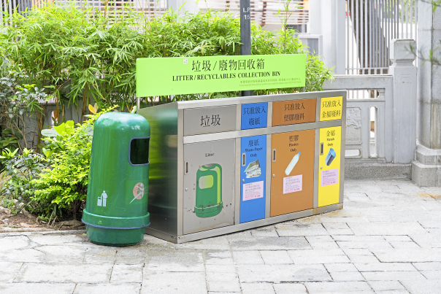

1. Dein Vater hat diesen Artikel über Müll in Hongkong entdeckt. Er interessiert sich für Umweltschutz,
aber versteht nicht alles in dem Text.
Beantworte seine Fragen.
a) Warum hat Hongkong ein Müllproblem?
b) Wie viel Müll produziert Hongkong?
c) Was tut die Stadt, um das Problem zu lösen?


2. Work with a partner. Think of some solutions to Hong Kong’s rubbish problem.
Make a list of ideas and present them in class.

